Purpose and Scope
This chapter defines the User Interface (UI) architecture of the Welding Quality Control System.
The UI architecture supports:
- Real-time monitoring of welding process parameters
- Objective evaluation of weld quality (PASS / FAIL)
- Traceable presentation of production data
- Controlled system operation in industrial and kiosk environments

Design Principles
The UI architecture is developed based on the following principles:
- Process Transparency – All critical process data is visible in real time
- Error Prevention (Poka-Yoke) – QR generation and printing are restricted to PASS results only
- Traceability – Every weld cycle is associated with model, timestamp, and measured values
- Access Control – Configuration and shutdown actions are password-protected
- Deterministic Layout – Fixed layouts prevent operator confusion and misinterpretation
- Continuous Operation – Designed for 24×7 industrial use without manual intervention

Overall UI Layout Architecture
The system UI is organized into five permanent functional zones:
- Application Header
- Real-Time Process Visualization Area
- Weld Result Evaluation Area
- Latest Cycles Summary Area
- System Footer
All zones remain consistently positioned across screens to ensure operator familiarity and audit consistency.
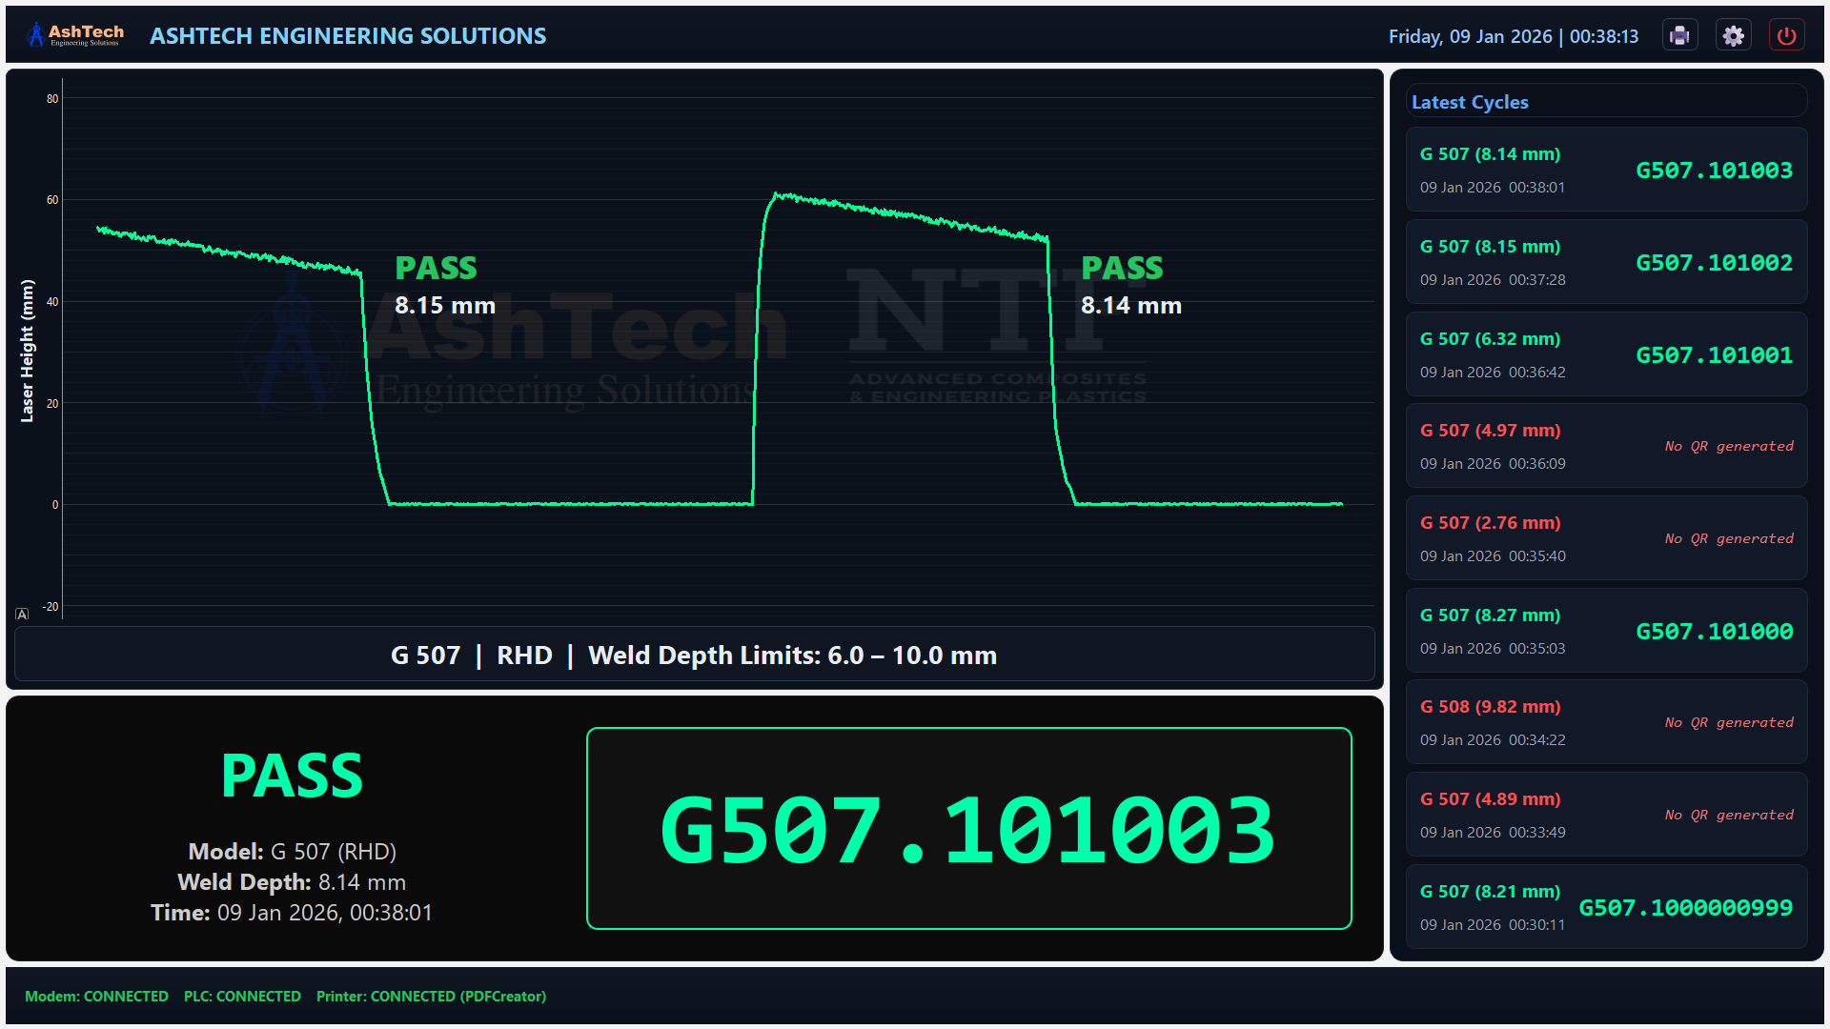

Application Header – System Identification & Control
The Application Header provides system identification, real-time clock reference, and controlled operator actions.
- Fixed-height industrial header (non-resizable)
- Company logo and system name
- Live date and time display (system clock)
- Icon-only action controls:
  - Print (QR label printing)
  - Settings (password-protected)
  - Shutdown (available only in kiosk mode)

Real-Time Process Visualization – Plot Panel
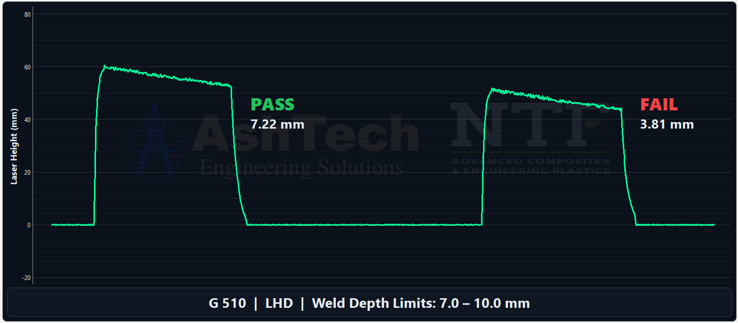
The Plot Panel provides continuous real-time visualization of laser welding signals.
Features:
- Live waveform of laser height versus time
- Fixed time window with automatic scaling
- Visual weld cycle annotations
- Clear PASS / FAIL indication with measured weld depth
- Display of model-specific acceptance limits
- Branding watermark for system identification

Weld Result Evaluation – Result Panel
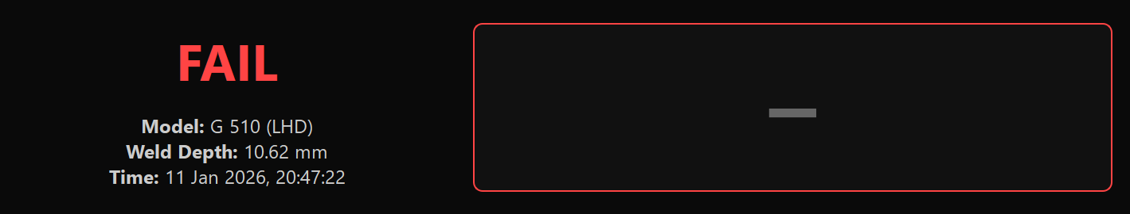
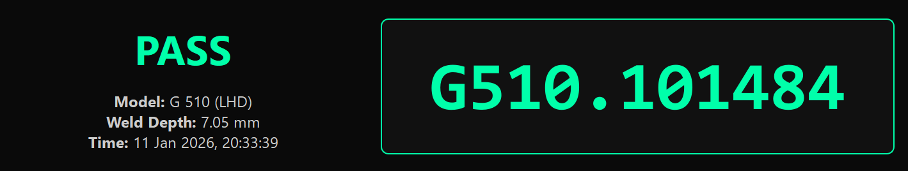
The Result Panel presents the final quality decision for each weld cycle.
Features:
- Large PASS / FAIL display with color coding
- Weld depth measurement display
- Model name and model type
- Time-stamped cycle completion record
- QR code text display (PASS cycles only)
- Adaptive font sizing for variable-length QR data
Understanding Results Panel,
- PASS
  - Weld depth within configured limits
  - QR code generated automatically
  - Part allowed to move to next process
- FAIL
  - Weld depth outside limits
  - No QR code generated
  - Part must be segregate

Latest Cycles Summary – Cycles Panel
The Cycles Panel provides a compact historical view of recent production cycles.
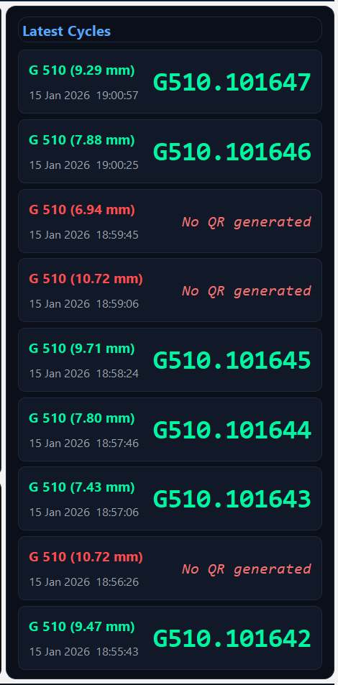
Features:
- Displays latest completed cycles (newest first)
- PASS / FAIL clearly highlighted per cycle
- Model name, weld depth, and timestamp
- QR code displayed only for PASS cycles
- Fixed-height, non-scrollable layout for stability

System Footer – Status & Notification Panel
The Footer Panel provides continuous system health monitoring and notification feedback.
Features:
- Live status indication for:
  - PLC communication
  - GSM modem
  - USB printer
- SMS notification display with:
  - Recipient
  - Timestamp
  - Message content
  - Controlled scrolling for long messages
  - Automatic message timeout and clearance

Main Application Control & Workflow

System Behavior:
- Automatically loads the active welding model
- Continuously receives and displays laser data
- Updates all UI panels upon cycle completion
- Synchronizes plot, result, and cycle history
- Maintains layout consistency throughout operation

Kiosk Mode Controls:
- Full-screen operation
- Cursor auto-hide after inactivity
- No accidental window switching
- Controlled shutdown sequence with confirmation

Controlled Shutdown & Safety
- Shutdown Confirmation
- Password-protected access
- Explicit confirmation dialog
- Warning to ensure no active weld cycle
- Safe application termination

QR Label Printing (Operator)

Automatic Printing
- PASS parts are queued automatically
- Labels are printed without manual action
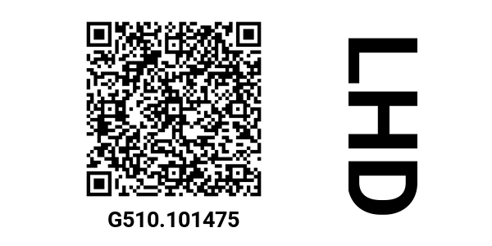

Manual Printing (Pending Queue)
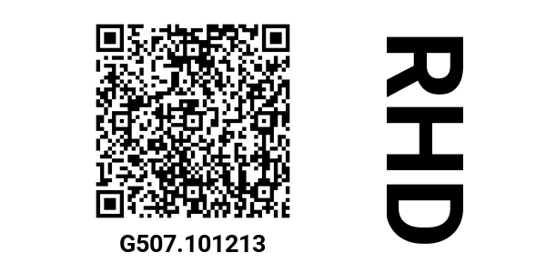

Open QR Printing
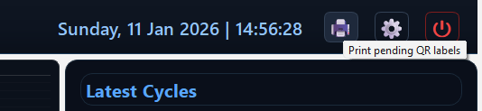

- Select “Pending QR Labels”
- Select required rows
- Click Print Selected
- Confirm print
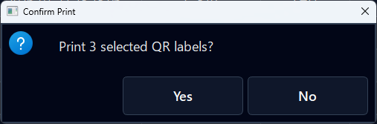

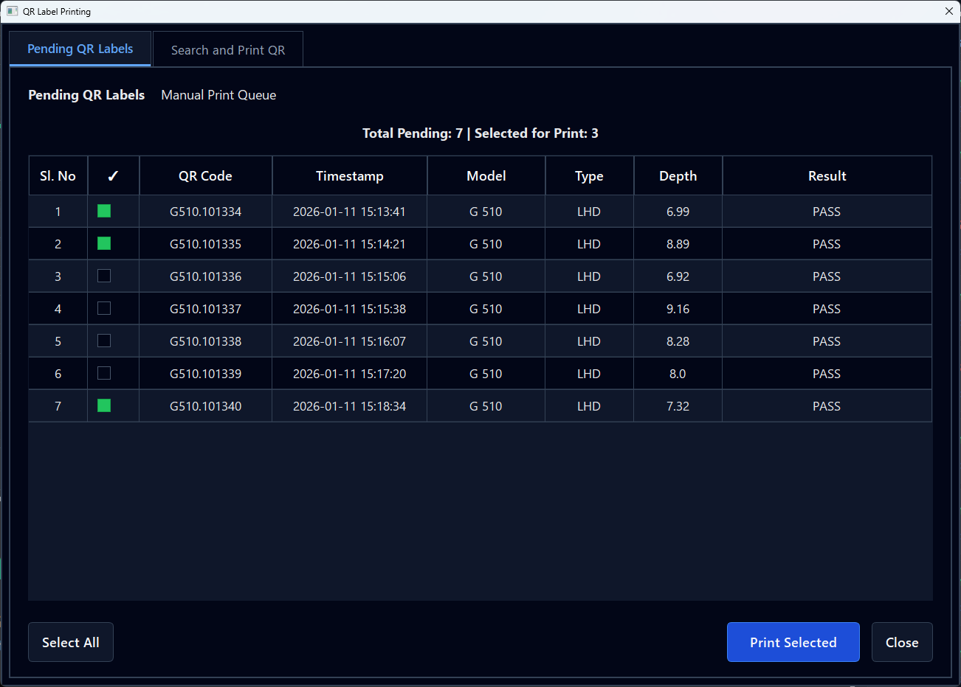

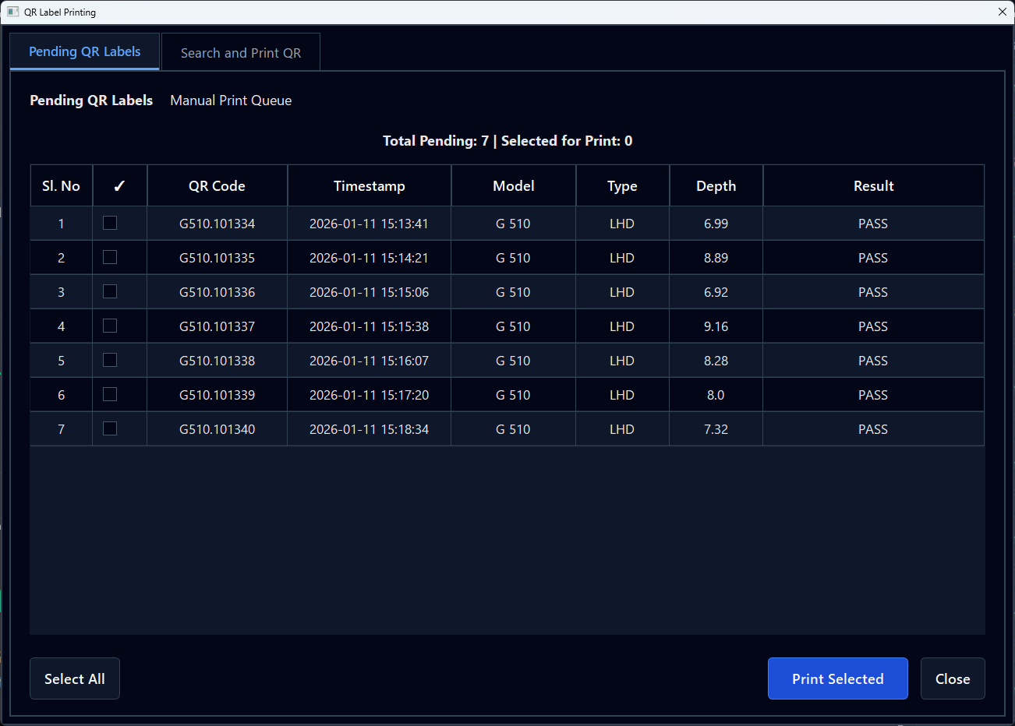

Manual QR Search & Reprint
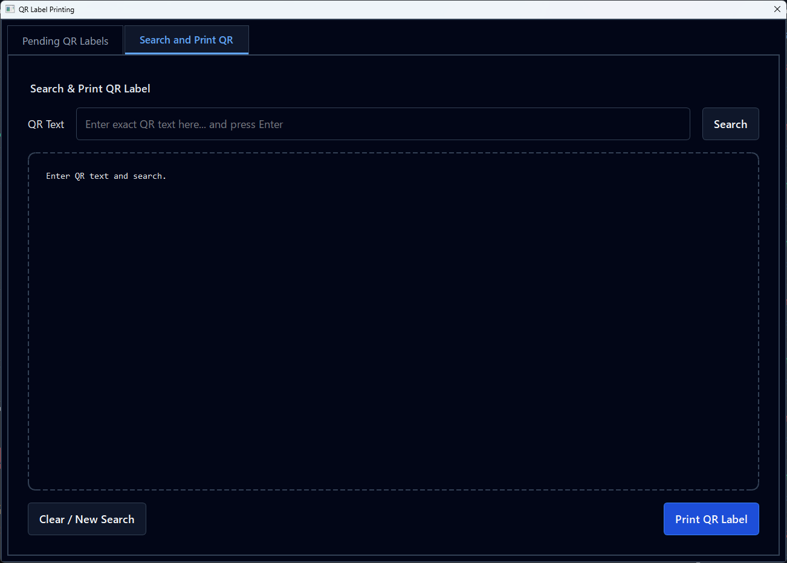

When to Use
- QR label damaged
- Printer failure during print
- Audit or verification request

Steps
- Open Search & Print QR
- Enter exact QR text
- Click Search
- Verify preview details
- Click Print QR Label
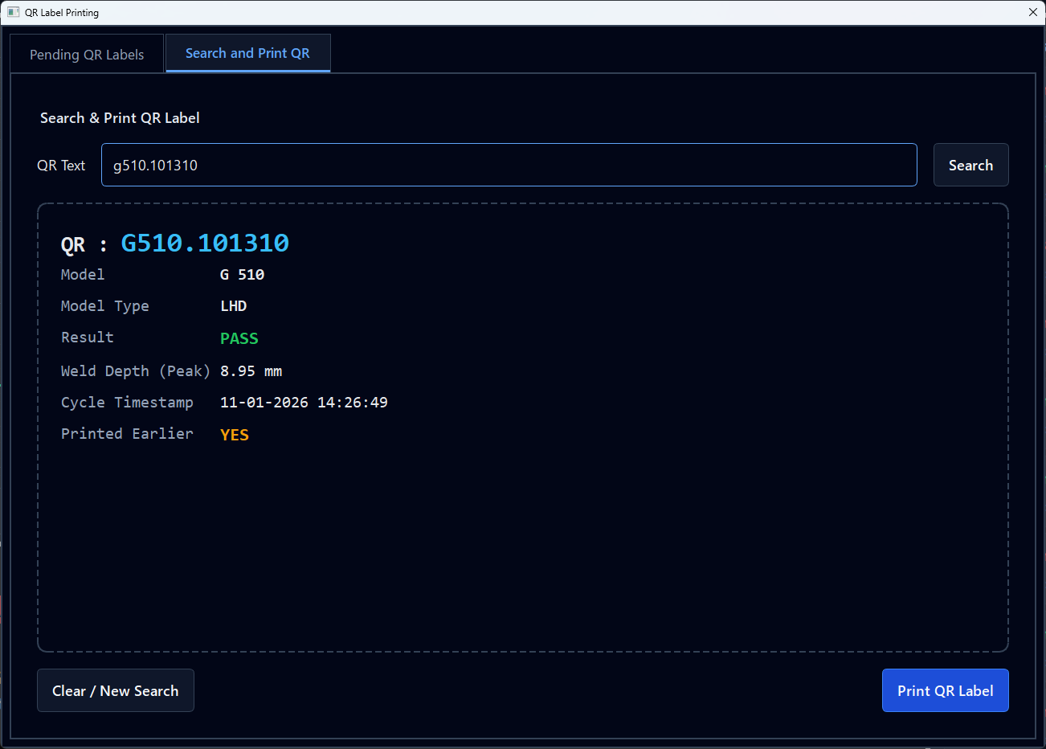

Operator Access & Security
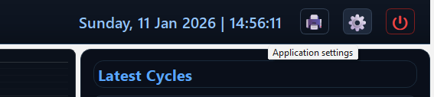

Operator access is protected by a settings password.
Protected functions include:
- Model management
- QR configuration
- Alert contact management
- System shutdown
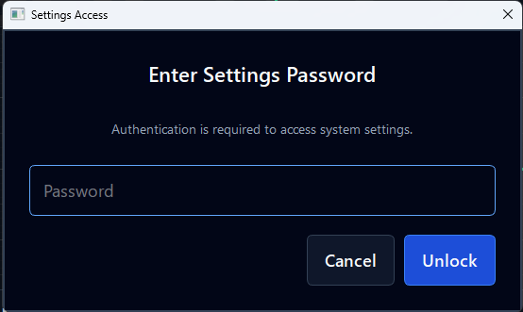

Model Management
Each model represents a product with:
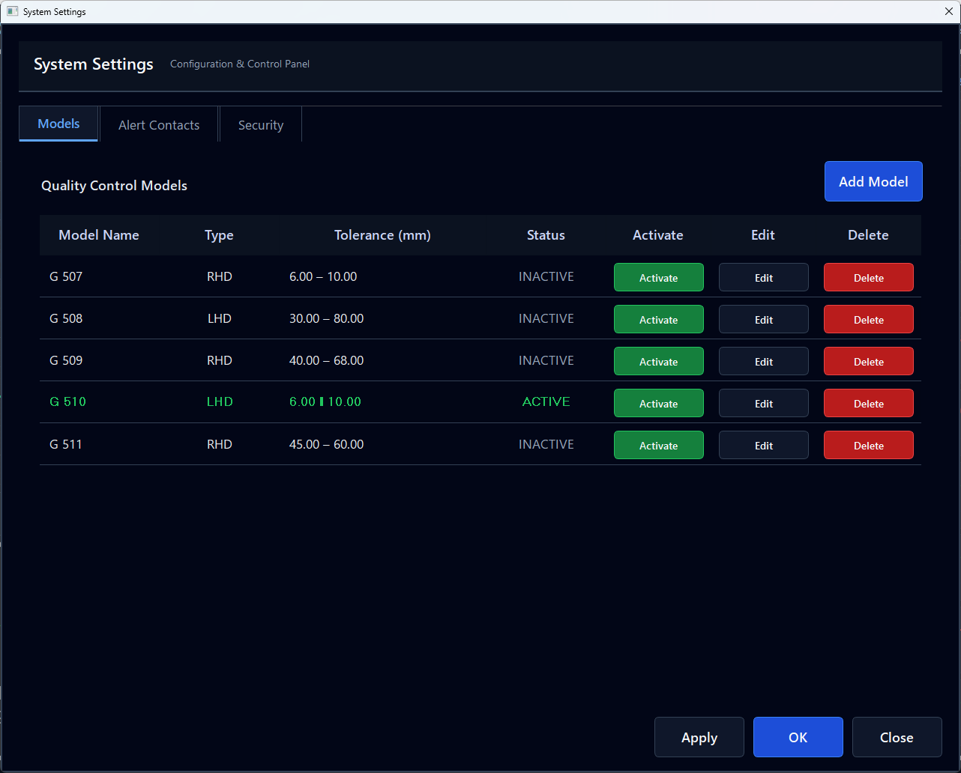

- Welding tolerance limits
- Model type (RHD / LHD)
- QR behavior
Supervisor Actions
- Add new models
- Edit tolerance limits
- Activate one model at a time
- Delete inactive models only
✔ Only one model can be active
✔ Active model is clearly highlighted in green colour

Model Activation & QR Rules
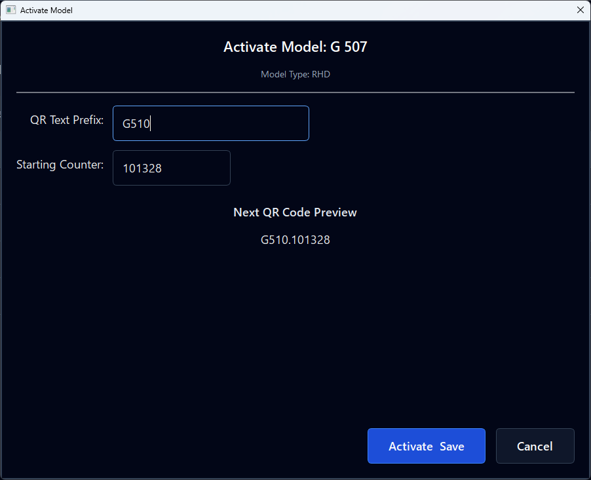

During Activation, Supervisor can:
- Set QR prefix
- Set starting QR counter
- Preview next QR label
✔ Prevents duplicate QR codes
✔ Ensures traceability consistency

Add and Edit Models
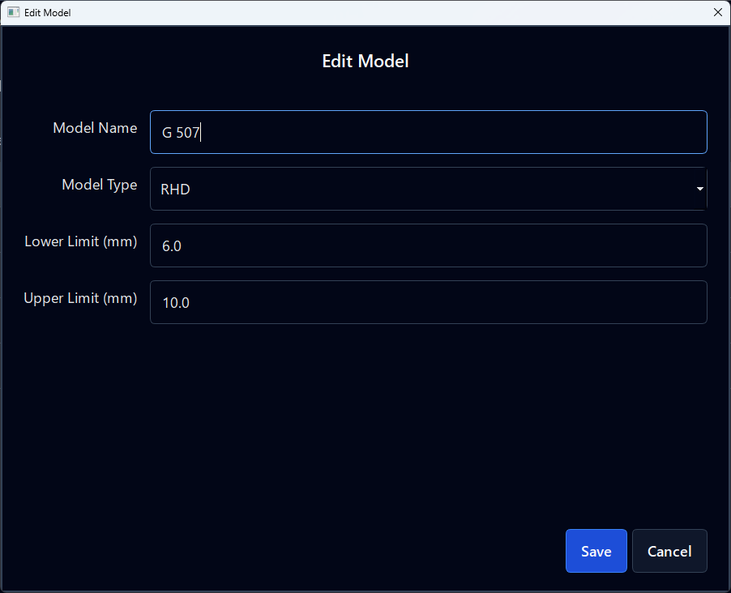

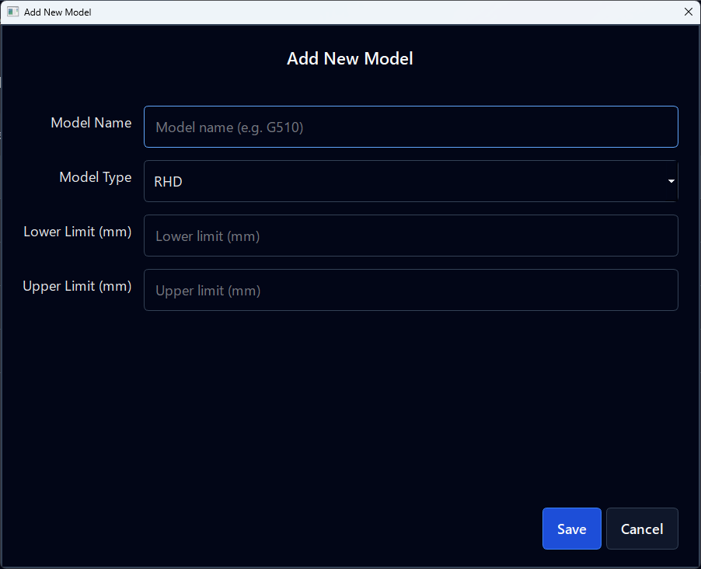

Alert Contact Management
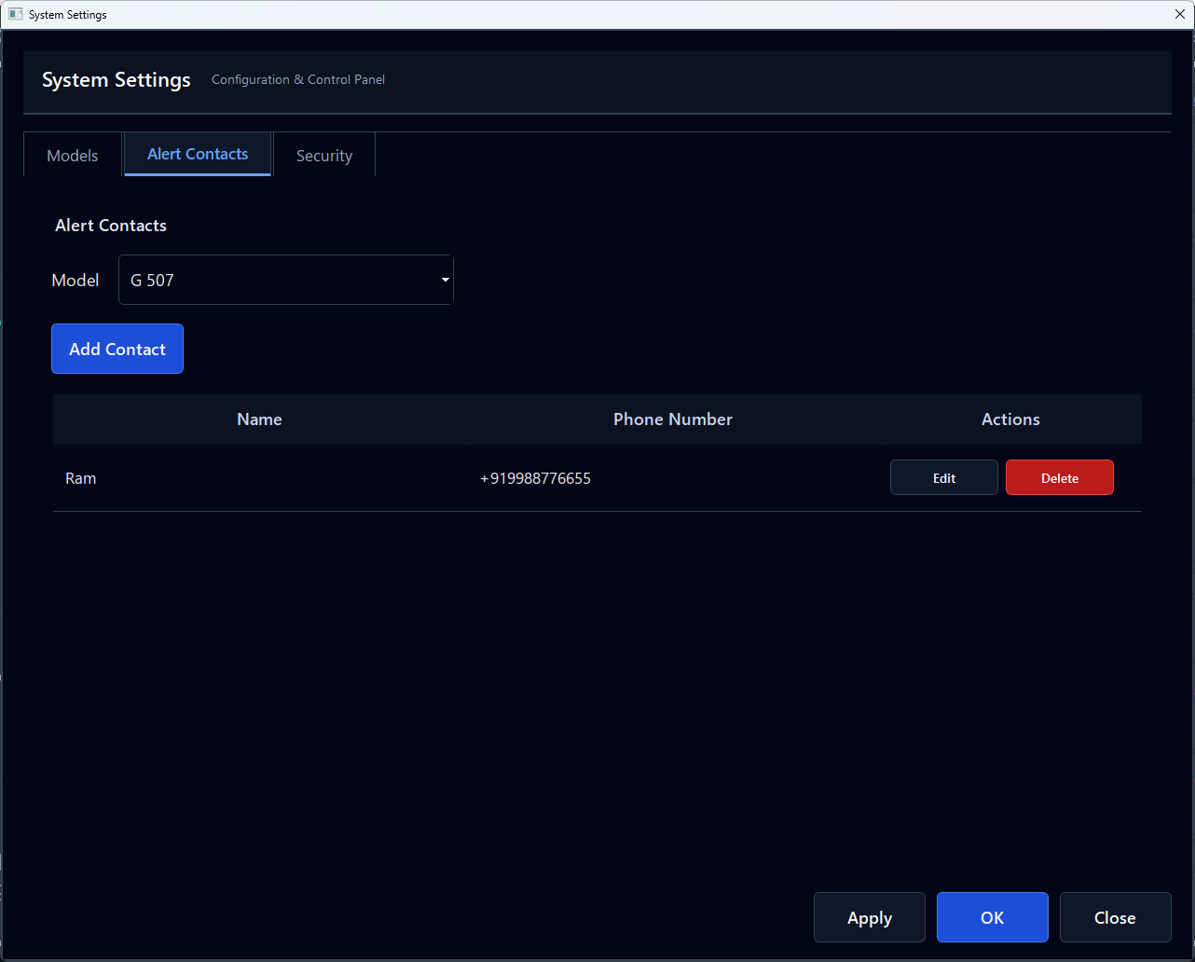

Define who receives SMS alerts for quality/system events.
- Model-specific contacts
- Add / Edit / Delete contacts
- Phone number validation

Password Management
- Maintain confidentiality
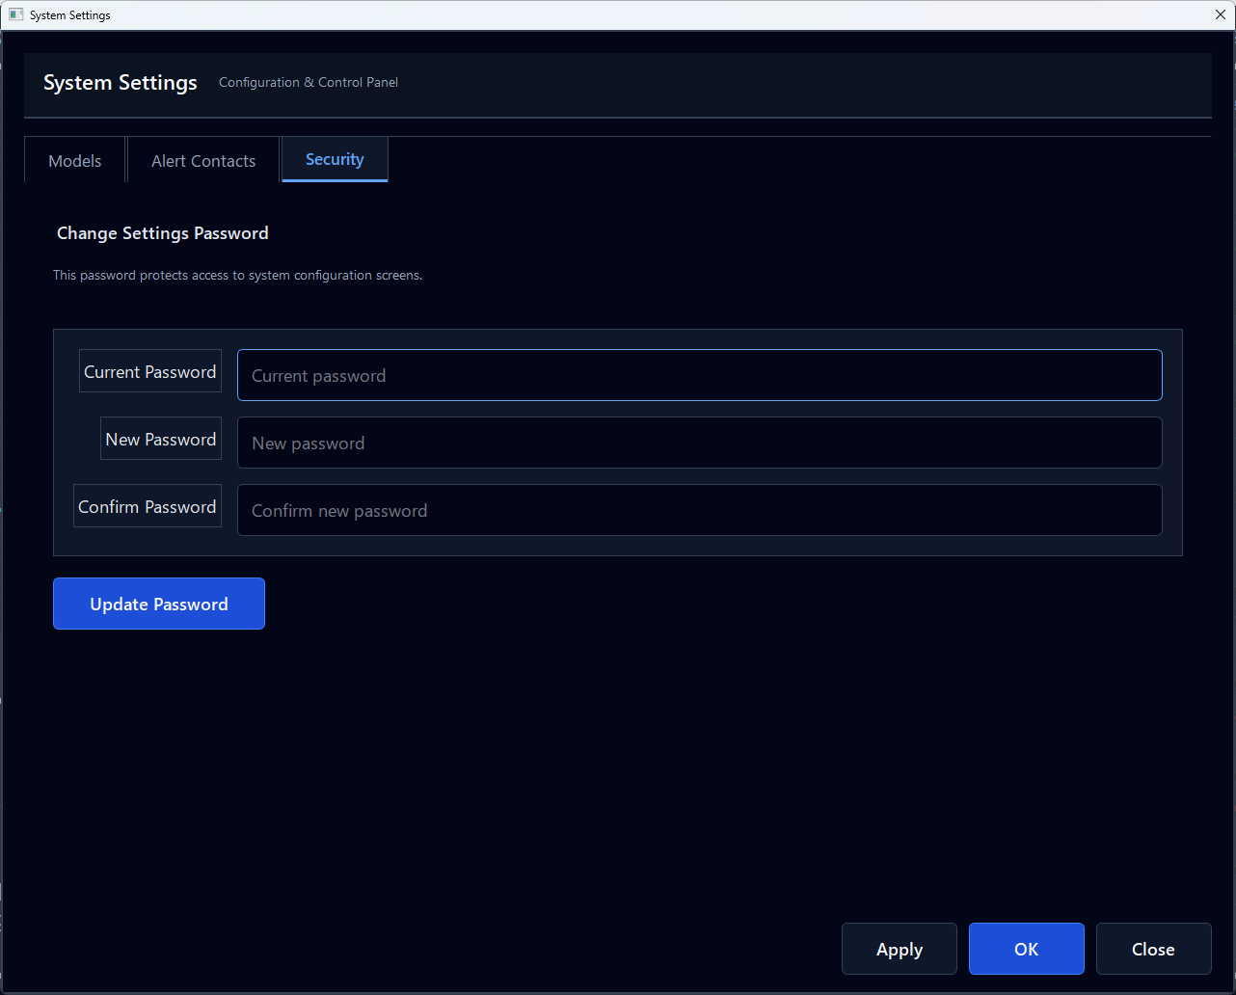

- Change password periodically
- Ensure only authorized access

Safe Shutdown Procedure
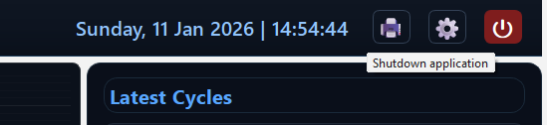

- Authenticate with password
- Confirm shutdown warning
- Ensure no active cycle is running
- Exit application safely

